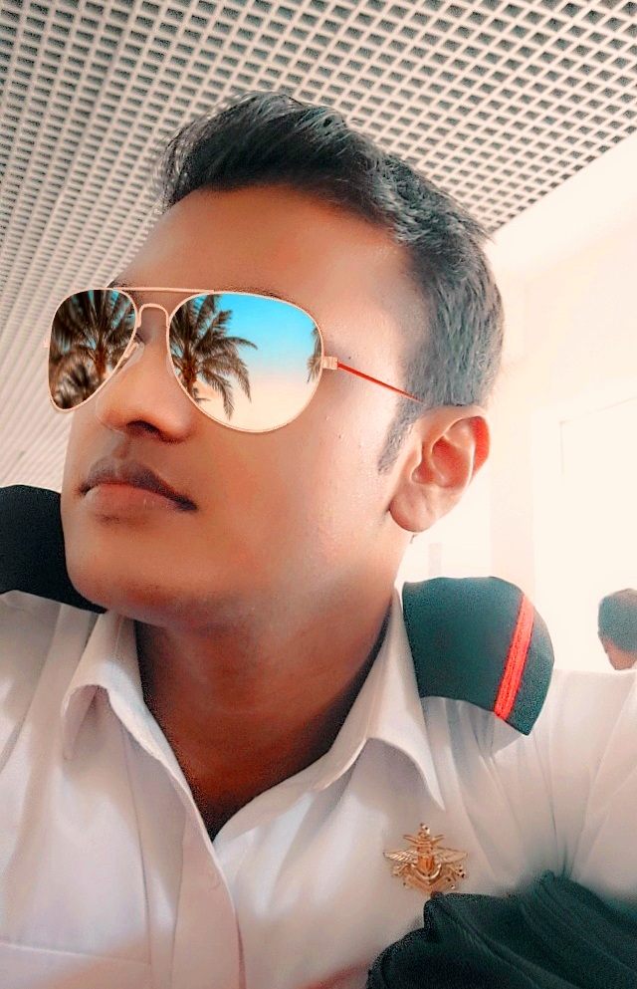

**M.T.M Dilshan**

**OBJECTIVE**

Seeking a challenging position in a reputed organization where I can learn new skills, expand my knowledge, and leverage my learnings. To get an opportunity where I’m able to make the best of my potential and contribute to the organization’s growth.

**EDUCATIONAL QUALIFICATIONS - ACADAMIC**

* **Following BSc Computer Science in General Sir John Kotelawala Defence University.**
* Passed **G. C. E. Advanced Level Examination** in **Math Stream** with **“3C”** passes for **Combined Mathematics, Physics** and **Chemistry**.
* Passed **G. C. E. Ordinary Level Examination** with **4A** passes, **3B** passes, and **2C** passes.

(Sinhala, Buddhism, Math, Science, History, English, Business Studies, ICT, Art)

**OTHER QUALIFICATIONS**

* Successfully completed English Diploma Course at Pearson University, London.

**EXTRA-CURRICULAR ACTIVITIES**

* 9th KYU – Yellow belt in the art of Goju-Ryu-Karate-Do
* Member of Science Society (School)
* Member of IEEE (KDU).
* Member of ERIC (KDU).
* Member of Rotaract Club (KDU).

**SPORTS**

* Karate
* Rugby
* Cricket
* Athletic

**324/E, Jayanthi Mawatha, Padukka, Colombo, Sri Lanka**

**+94 76 977 1656/ +94 75 186 3328**

**mthurunu@gmail.com**

**Name in Full : Malage Thurunu Mihiranga Dilshan**

**Date of Birth : 15.11.2000**

**Age : 22 years**

**School :**

**Gender : Male**

**Civil Status : Single**

**Nationality : Sri Lankan**

**NIC No : 200032000294**

**D. Licence no :**

* **Ability to calm under pressure.**
* **Honesty and integrity.**
* **Effective problem-solving skills.**
* **Have a strong desire to learn and ability to learn quick and attention to details.**
* **Quality of works 100% guaranteed.**

**CONTACT INFORMATION**







**PERSONAL INFORMATION**

**Siri Piyarathana National College, Padukka**

**KEY SKILLS & COMPETENCIES**

**NON-RELATED REFEREES**

* **Mr. Namal J Premawardane**

Supreme Court Advocate

Mobile : 071 518 1916

* **Mr. Janaka Sirimanna**

Excise Officer

Mobile : 071 447 7746

I do hereby certify that the above particulars furnished by me are true and accurate to the best of my knowledge.

……………………………….

MTM Dilshan.

Date :

